LDA Topic Modelling Report on the Ansar1 Forum Dataset
A Comprehensive Analytical & Visual Summary

1. Dataset Overview
The Ansar1 Forum Dataset, created by the University of Arizona’s Artificial Intelligence Lab, contains online extremist forum discussions from December 2008 to January 2010.
Dataset Summary
- 📝 Total Posts: 29,492
- 🧵 Threads: 11,244
- 👥 Members: 382
- 🌐 Language: English
- 📄 Format: Plain text (unzipped ~52 MB)
- 📥 Loaded into Notebook: 28,866 documents
This dataset primarily includes news reposts, religious commentary, militant updates, and personal discussions.

2. Workflow Overview
The analysis consists of five major phases:
- Library & Environment Setup
- Dataset Loading
- Text Preprocessing (spaCy-based)
- Dictionary & Corpus Creation (Gensim)
- LDA Topic Modeling (10 topics)
- Document Categorization
- Visualization & Insights
A clean visual summary of the workflow:
Dataset → Cleaning → Tokenization → Lemmatization → Dictionary → Corpus → LDA Model → Topic Assignment → Visualization

3. Detailed Preprocessing Pipeline (Very Crucial Section)
The preprocessing pipeline ensures clean, meaningful tokens for topic modeling. Below is a structured, clear explanation of each transformation.
Step-by-Step Text Preprocessing
📌 1. Convert to String
Every document is cast to string format to avoid errors from numeric entries or missing values.
📌 2. Remove URLs
All web addresses (http, https, www) are removed using regex. This prevents hyperlinks from becoming dominant tokens.
📌 3. Remove Non-English Characters
A corrective filter removes everything except English letters and spaces.
This removes:
- Arabic text
- Numbers
- Emojis
- Punctuation
- Special characters
This dramatically improves token quality.
📌 4. Tokenization with spaCy
spaCy splits each sentence into linguistic tokens.
📌 5. Stopword Removal
Words like "the", "and", "is", etc., are excluded because they add no semantic meaning.
📌 6. Alphabetic Filtering
Only pure alphabetic words are retained.
📌 7. Lemmatization
Words are reduced to their root forms:
- “running” → run
- “killed” → kill
- “Islamists” → islamist
This reduces vocabulary noise and improves clustering.
📌 8. Minimum Length Filtering
Tokens with fewer than 3 characters are removed.
✨ Output of Preprocessing
Each document becomes a clean list of meaningful lemmas ready for topic modeling.
Example:
Before:
“In the Name of Allah the Most Merciful http://example.com”
After:
["allah", "merciful", "name"]

4. Building Dictionary & Corpus
✔ Dictionary
Maps each unique word to an ID.
✔ Filtering
- Words appearing in fewer than 5 documents removed
- Words appearing in more than 50% of documents removed
✔ Corpus
Each document becomes a Bag-of-Words vector of (word_id, frequency) pairs. This corpus is the input to the LDA model.

5. LDA Topic Model Training
The Latent Dirichlet Allocation model was trained with:
- 10 topics
- 10 passes through corpus
- Fixed random seed (100)
- Gensim’s LdaModel implementation
The model outputs topic-word distributions and document-topic probabilities.

6. LDA Topics with Custom Labels
Your custom topic labels add interpretability. The following table shows the top words and weights per topic:
🟦 LDA Topic Table (with Weights & Labels)
Topic | Label | Top Keywords & Weights
0 | Somalia & Shabaab News | somalia (0.045), somali (0.027), government (0.022), mogadishu (0.016), shabaab (0.014)...
1 | General Islamic Topics | islamic (0.023), people (0.013), muslims (0.013), jihad (0.012), god (0.008)...
2 | Pakistan & Taliban Conflict | pakistan (0.034), taliban (0.034), attack (0.019), militant (0.019)...
3 | Israel–Palestine Conflict | israel (0.038), israeli (0.031), hamas (0.030), gaza (0.028)...
4 | Iraq Conflict & Attacks | kill (0.029), police (0.023), attack (0.018), soldier (0.016)...
5 | Personal / Court Cases | man, year, woman, court, family...
6 | Afghanistan Mujahideen Reports | mujahideen (0.040), emirate (0.026), afghanistan (0.025)...
7 | Global/Nuclear Weapons | weapon, war, nuclear, cia, russia...
8 | Forum Chat & Religious Posts | allah (0.053), brother, quote, post, video...
9 | US/Afghanistan Policy (Obama) | afghanistan, troop, government, obama...

7. Categorization of All Documents
Each of the 28,866 documents was tagged with the topic having the highest probability.
Sample Output:
Text (shortened) | Category | Confidence
Religious invocation | Forum Chat & Religious Posts | 64.36%
Article link | Global/Nuclear Weapons | 40.30%
Iraq news | Iraq Conflict & Attacks | 78.43%

8. Topic Distribution (Visualization Added)
Below is a horizontal bar chart showing how many documents belong to each topic category:
📊 Topic Distribution Chart
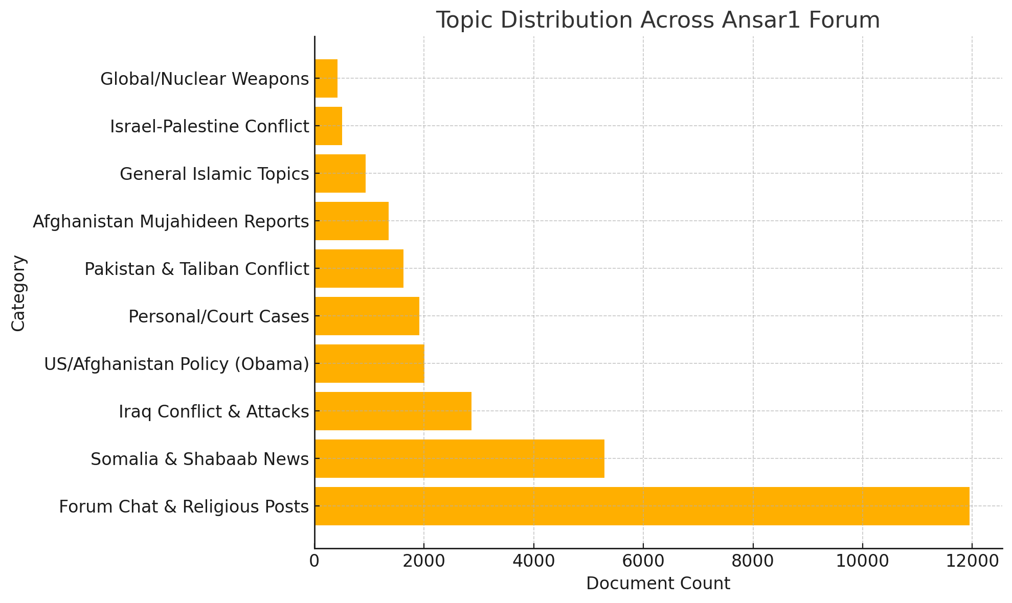
This chart visually highlights:
- Dominance of Forum Chat & Religious Posts
- High presence of Somalia & Shabaab News content
- Moderate coverage of Iraq, Afghanistan, Pakistan, and US Policy
- Relatively small discussion of Israel-Palestine and Nuclear issues

9. Visualization of Topics
To visually interpret the structure of the topics generated by the LDA model, an interactive topic visualization was created using pyLDAvis. This tool provides an intuitive way to explore how topics relate to each other and what keywords define each topic.

9.1 pyLDAvis Interactive Topic Map
The pyLDAvis interface shows:
- Intertopic Distance Map (Left):
Each circle represents a topic.
The size of the circle indicates how common the topic is in the dataset, and the distance between circles shows how similar or different the topics are.
- Top Terms for Selected Topic (Right):
When a topic is selected, its most relevant keywords and their frequencies are displayed.
This visualization helps in quickly identifying dominant themes, overlapping topics, and keyword importance.

Topic 1:

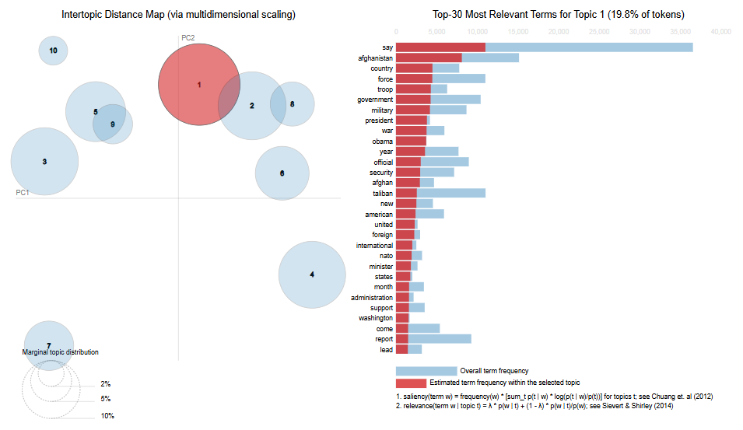

Topic 6:
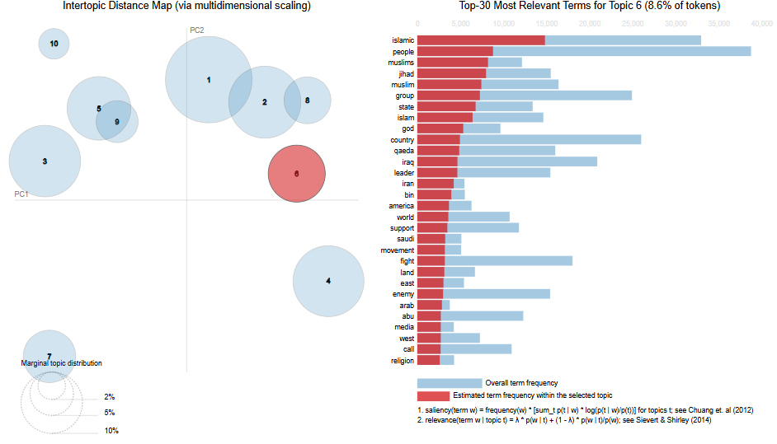

Topic 10:
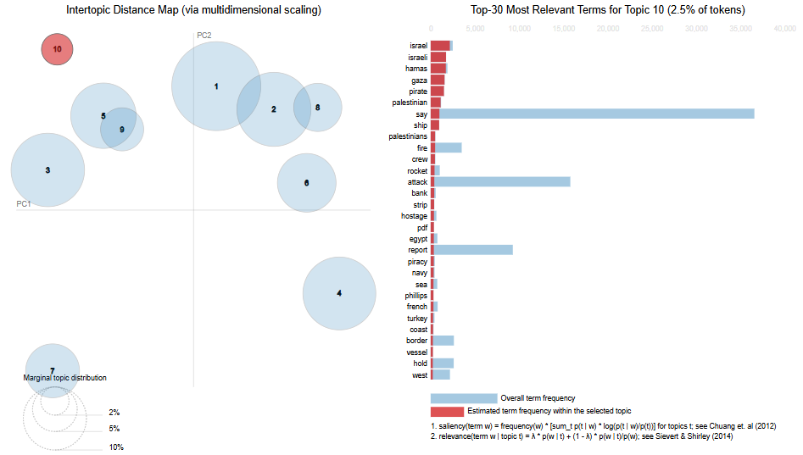

9.2 Topic Distribution Chart
A bar chart was also generated to show how many documents fall under each topic.
This provides a clear overview of which themes are most frequently discussed in the Ansar1 forum.
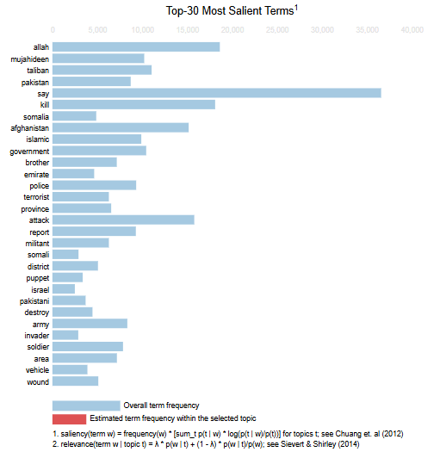
9.3 Topic Word Clouds
Word clouds were created for all ten topics to visually highlight the most important terms.
Larger words represent higher weight within a topic.
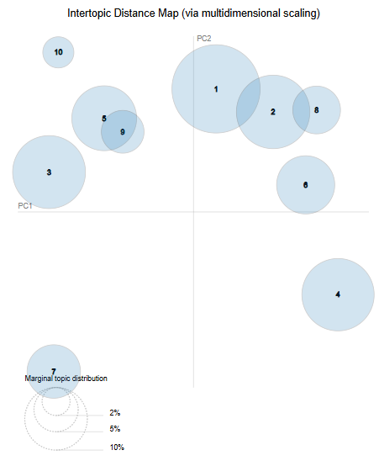

10. Key Insights
🔹 Forum behavior
A large portion of the dataset is conversational and religious, rather than strictly news.
🔹 Regional focus
Somalia receives surprising emphasis, suggesting targeted ideological interest.
🔹 Conflict-heavy themes
Iraq, Afghanistan, Pakistan, and Palestine appear frequently, consistent with global events during 2008–2010.
🔹 US policy under Obama
The forum discusses U.S. involvement in Afghanistan intensively.

11. Conclusion
This LDA-based analysis reveals that:
- The Ansar1 forum blends religious discussion, militant updates, and global conflict commentary.
- The preprocessing pipeline ensures clean and meaningful input for topic modeling.
- Visual charts clearly highlight dominant themes and community behavior.
- The 10-topic LDA model provides a structured understanding of the entire dataset.

